IT5512- WEB TECHNOLOGY LAB-SESSION-4
DATE: 27/09/2021 FN
NAME: A.S. PRUTHIEV
REG NO.2019506067
PASS AND RETURN BY REFERENCE

1) AIM:
To write a java program to pass the object as reference

ALGORITHM:
- Create a class Student with private varaibles name,roll number,gender
- Create a constructor intializing the values
- Create a getter methods for each variables
- Create a ArrayList of students and enter the n student objects
- Enter the student details that is to be searched for
- Create own equalTo function to compare the objects and return accordingly
PROGRAM CODE:
package Java.Lab.Lab4;

public class Student{
private int age;
private String name,rollNumber;
double cgpa;
public Student(int age, String name, String rollNumber, double cgpa) {
this.age = age;
this.name = name;
this.rollNumber = rollNumber;
this.cgpa = cgpa;
}
public Student(Student s){
this.name = s.name;
this.age = s.age;
this.rollNumber = s.rollNumber;
this.cgpa = s.cgpa;
}
public int getAge() {
return age;
}
public String getName() {
return name;
}
public String getRollNumber() {
return rollNumber;
}
public double getCgpa() {
return cgpa;
}
public boolean equalsTo(Student y) {
return (this.age == y.age && this.name.equals(y.name) && this.rollNumber.equals(y.rollNumber)
&& this.cgpa == y.cgpa);
}
}

public class PassAndReturnReference1 {
private static final Scanner input = new Scanner(System.in);
public static void main(String[] args) {
int n;
System.out.print("Enter the number of students :");
n = input.nextInt();
ArrayList<Student>students = new ArrayList<>(n);
int age;
String name,rollNumber;
double cgpa;
for(int i = 0 ; i < n ; i++){
input.nextLine();
System.out.print("Enter the name of the student :");
name = input.nextLine();
System.out.print("Enter the age and roll number :");
age = input.nextInt();
rollNumber = input.next();
System.out.print("Enter the cgpa :");
cgpa = input.nextDouble();
students.add(new Student(age,name,rollNumber,cgpa));
}
input.nextLine();
System.out.print("Enter the name or the student to be searched for :");
name = input.nextLine();
System.out.print("Enter the age and roll number to be searched for : ");
age = input.nextInt();
rollNumber = input.next();
System.out.print("Enter the cgpa to be searched for : ");
cgpa = input.nextDouble();
Student find = new Student(age,name,rollNumber,cgpa);
Student found = students.stream().filter((x) -> x.equalsTo(find)).findFirst().orElse(null);
if(found != null){
System.out.print("The student is present at index " + students.indexOf(found));
}

}
}

OUTPUT:
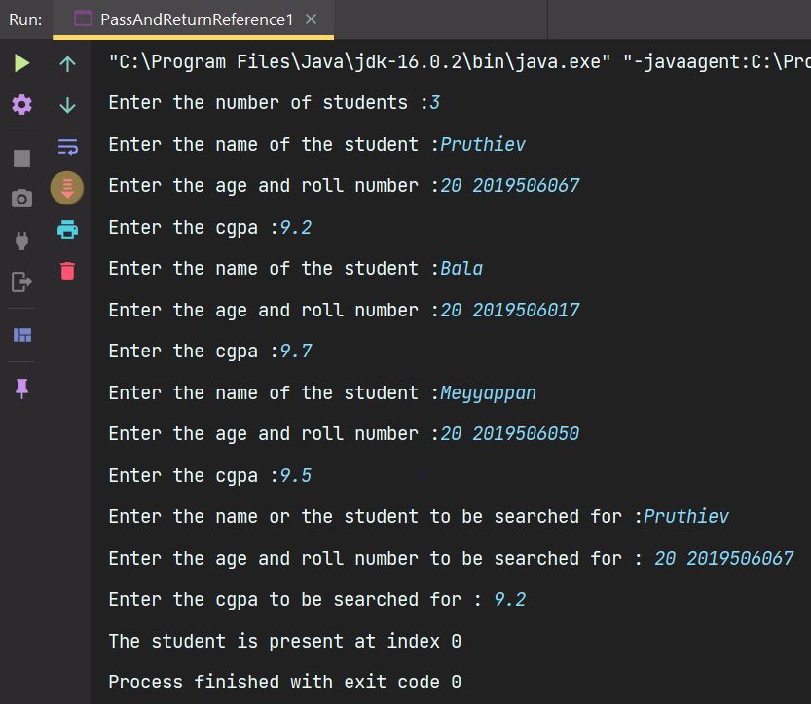

RESULT:
Thus, the program has been executed successfully.

2)
AIM:
To write a java program to pass and return by reference

ALGORITHM:

- Create a class Student with private varaibles name,roll number,gender
- Create a constructor intializing the values
- Create a getter methods for each variables
- Create three student objects
- Create a student object by a copy constructor and another student object using equal to another student object
- Compare them using == operator and equals functions and the output the results accordingly

PROGRAM CODE

package Java.Lab.Lab4;

import java.util.Arrays;

public class PassAndReturnReference2 {
public static void main(String[] args) {
Student st1 = new Student(20,"Pruthiev","2019506067",9.3);
Student st2 = new Student(20,"Bala","2019506017",9.7);
Student st3 = new Student(19,"Meyyappan","2019506050",9.5);
Student st4 = new Student(st1);
//st4 creates new student object so the reference of st1 and st4 are differently allocated on heap
Student st5 = st1;
//st5 now points to st1 and both refer to the same object in the heap
if(st1 == st4){
System.out.println("They are same compared by = symbol");
}
else System.out.println("They aren't same as they are compared by = symbol");
if(st1.equalsTo(st4)){
System.out.println("They are same as they are compared by equalsTo user defined function");
}
else System.out.println("They aren't same as they are compared by equalsTo user defined function");
if(st1 == st5){
System.out.println("They are same compared by = symbol");
}
else System.out.println("They aren't same as they are compared by = symbol");
if(st1.equalsTo(st5)){
System.out.println("They are same as they are compared by equalsTo user defined function");
}
else System.out.println("They aren't same as they are compared by equalsTo user defined function");
Integer []p = new Integer[]{1,2,3,4,5};
Arrays.sort(p);
System.out.println(Arrays.toString(p));
}

}

OUTPUT:
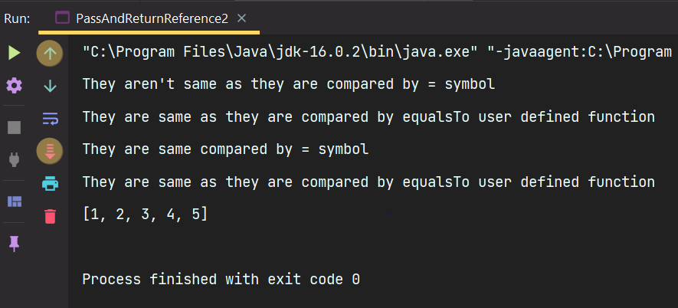

RESULT:
Thus, the program has been executed successfully.

